**KRAKEN SET TO COMMENCE HUNT**

**FOR AVRO ARROW ARTIFACTS**

## *Kraken to Deploy Its ThunderFish® Robot and AquaPix® Sonar During Search*

**ST. JOHN’S, NEWFOUNDLAND, 14 JULY 2017** /Marketwired/ -- Kraken Sonar Inc. (TSX-V: PNG) (OTCQB: KRKNF) announced today that its wholly-owned subsidiary, Kraken Sonar Systems Inc. has been awarded its first “Robotics as a Service” contract by OEX Recovery Group Incorporated, to conduct the search for nine Avro Arrow free flight models launched over Lake Ontario in series of tests during 1954 - 1957. The models are one-eighth scale replicas of the famed flying jet, and were part of the final flight design tests done prior to the production of the CF-105 Arrow. The goal of the search is to discover the resting place of nine models, recover them and ultimately house them at the Canada Aviation and Space Museum in Ottawa and the National Air Force Museum of Canada in Trenton, Ontario. While contract terms between Kraken and OEX are confidential, the contract amount is less than C$500,000.

The search and recovery program is a Canada 150 collaborative effort spearheaded by Osisko group companies Osisko Mining Inc. and Osisko Gold Royalties Ltd., in collaboration with their financial partners at National Bank, the Bank of Montreal, Canaccord Genuity, Maxit Capital, Eight Capital and Northfield Capital; the Canada Aviation and Space Museum (CASM), Royal Canadian Air Force (RCAF), the Canadian Conservation Institute and Bennett Jones LLP. Support for this project is also being provided by the Canadian Coast Guard, the Royal Canadian Military Institute and Canada Company.

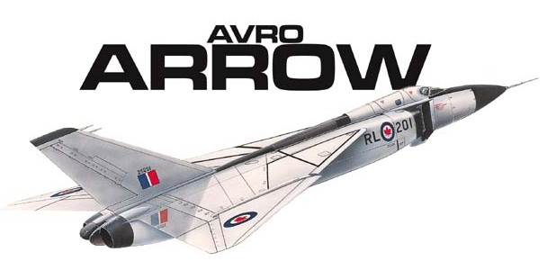Later this month Kraken will deploy its ThunderFish® Autonomous Underwater Vehicle (AUV) and AquaPix® Synthetic Aperture Sonar (SAS) system in Lake Ontario to search for the Avro Arrow models. The highly-advanced Canadian jet fighter and development program was abruptly cancelled in 1959 by the government of the day.

The CF-105 Arrow performed incredibly well during in-flight tests and many thought it would put Canada at the forefront of military aviation. When the program was cancelled in 1959, over 30,000 employees and sub-contractors lost their jobs as a direct result of the program’s cancellation. Many Avro engineers went on to work at Lockheed, Boeing and NASA, and others to Britain to work in the aerospace industry there. This is often cited as an example of Canadian Brain Drain.

When the program was cancelled, all materials related to the Avro Arrow were ordered destroyed, including six completed jet fighters, production tooling and all development-related materials. The only known artifacts from the program remaining to be found are the free flight test models, which for over sixty years have rested somewhere on the bottom of Lake Ontario. For Avro Arrow historians, the roughly one-eighth size models are something of a holy grail, since they were the flying replicas of the actual aircraft and the last step from design testing prior to production of the actual flying jets.

The free flight models were successively increased in sophistication, and were launched over Lake Ontario in a series of flights conducted between 1954 and 1957 to test the aerodynamic qualities of the aircraft design prior to a production model. The free flight models were attached to high-powered booster rockets and launched out over the lake from a military test site east of Toronto. After separating from the booster rockets the models flew at supersonic speeds. Their onboard sensors, revolutionary for the 1950s, transmitted flight data back to engineers on the ground. At the end of each flight the models lost velocity, crashed into the water and sank.

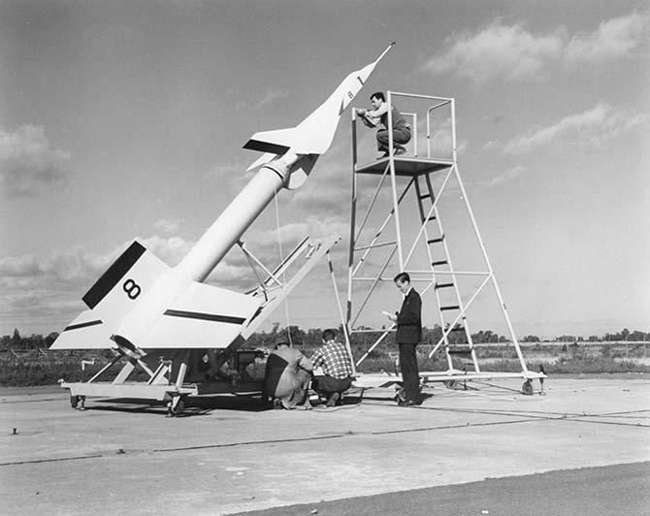

In the past, privately funded missions have attempted to locate and recover the lost models, but all have failed due inadequate funding, water depths, search area size and the amount of metal debris on the bottom - according to military records, more than 600 missiles were launched from the same site, which was also used as an artillery range in the 1930’s.

This summer's search for the Avro Arrow free flight models can be likened to the hunt for Sir John Franklin’s lost ships. The first vessel - the *HMS Erebus* - was discovered in September 2014 by a Canadian expedition team that included participation by Kraken engineers and its AquaPix® Synthetic Aperture Sonar technology. However, the Arrow free flight models are far smaller targets. While the full-size Arrow measured 24 metres long with a 15-metre wingspan, each free flight test model was just 3 metres long with a wingspan of 2 metres.

Like the hunt for Franklin’s lost ships, the search for the Arrow free flight models began with detailed analysis of historical information to narrow the search area as much as possible. In the Arrow’s case, scientists, engineers and historians from the Osisko group, Kraken and the RCAF used historical research, the collection of archival material at CASM, interviews with former Avro employees and computer-aided ballistic trajectory and flight data modeling to develop the search grids.

David Shea, Kraken’s VP of Engineering said, “We are very pleased to receive the first contract to validate our Robotics-as-a-Service business model - to build, own, operate and maintain our own vertically integrated robotic systems. ThunderFish® is a Kraken Autonomous Underwater Vehicle (AUV), using Kraken’s AquaPix® sonar and leveraging other Kraken-owned underwater technologies including batteries, thrusters, and artificial intelligence.”

Mr. Shea continued to say, “Our AquaPix® MINSAS technology provides extremely high-resolution images and unparalleled area coverage rates in a compact, low power package. Onboard real-time processing enables on-the-fly beamforming and geo-referencing, which significantly reduces the overall processing timeline, a critical factor in these types of search and salvage applications.”

“AquaPix® was a proven payload during the Franklin Expedition in 2014, operating onboard a Royal Canadian Navy AUV. We deployed the AUV in the morning, all processing occurred onboard the AUV in real-time, and after recovering the AUV in the evening we immediately began reviewing the already-processed sonar images, with zero post processing required. Leveraging what we’ve learned from that experience, I can say with confidence that we have the right people using the right technology for this expedition.”

Traditional sonar systems have a range and resolution limited by the size and frequency of their acoustic array. Kraken’s AquaPix® SAS technology provides an order of magnitude increase in range and resolution by using sophisticated software and signal processing to “synthesize” an array up to 25x longer than the real array. The AquaPix® SAS is integrated into Kraken’s ThunderFish® AUV – a battery powered, unmanned, untethered submersible. ThunderFish® is pre-programmed to survey a specific area each day. After deployment, it transits autonomously to the daily survey grid, dives to depth and surveys the area using the AquaPix® SAS and other sensors. Upon mission completion, it returns back to the shore for recovery, data download and battery charging.

John Burzynski, President and CEO of Osisko Mining Inc. and head of OEX Recovery Group Inc. stated: “As professional explorers in the mining business, we initiated this program about a year ago with the idea of bringing back a piece of lost Canadian history to the Canadian public. As individuals, as a company, as a group, and with our partners and our project participants in this search effort, we all have the same goal in mind: to find and return these beautiful pieces of Canadian technology to the public eye, during this anniversary year of our incredible country. Like Avro, our own corporate group was built on dreams and this project is a proud reminder of what we as Canadians have done, what we Canadians do, and what we Canadians can do.”

Karl Kenny, Kraken President & CEO said, “During our 150th birthday, I can’t think of a better example of how advanced Canadian ocean technology is being used to search and find advanced Canadian aerospace technology. This expedition is sure to be nostalgic for the countless fans of the Avro Arrow - which became a symbol of world-class Canadian technology. Continuing in the tradition of the Arrow, the entire Kraken team is very proud to engineer and build world-class Canadian underwater robotics technology.”

Famed Canadian journalist June Callwood, who passed away in 2007, summed up the impact of the program cancellation in a January 1997 *Maclean's* magazine article: "The Arrow seems to have touched a dream of perfection that enthralls many, and its destruction is a kind of soul-theft," Ms. Callwood said. "It was the most beautiful plane I will ever see. Even parked on its stilt legs on the tarmac, it made your heart ache. When it lifted straight up into the sky, a slim white arrowhead, it was poetry.”

Ms. Callwood said the Arrow had symbolized a Canadian pride and confidence: "It's not that we weren't proud of Canada's audacity in building the world's best combat airplane, superior to anything developed in the United States or the USSR. My point is that the Arrow didn't seem a fluke. We thought it natural that Canadians would be among the best, if not the best, at anything we really tried to do."

**ABOUT KRAKEN**

Kraken Sonar Inc. (TSX.V:PNG) (OTCQB: KRKNF) is a marine technology company, founded in 2012, that is dedicated to the production and sale of software-centric sensors and underwater robotic systems. The company is headquartered in St. John’s, Newfoundland with offices in Dartmouth, Nova Scotia; Bremen, Germany; and Fairfax, Virginia. For more information, please visit [www.krakensonar.com](http://www.krakensonar.com), [www.krakenrobotik.de](http://www.krakenrobotik.de), [www.krakenpower.de](http://www.krakenpower.de).

*Certain information in this news release constitutes forward-looking statements. When used in this news release, the words "may", "would", "could", "will", "intend", "plan", "anticipate", "believe", "seek", "propose", "estimate", "expect", and similar expressions, as they relate to the Company, are intended to identify forward-looking statements. In particular, this news release contains forward-looking statements with respect to, among other things, business objectives, expected growth, results of operations, performance, business projects and opportunities and financial results. These statements involve known and unknown risks, uncertainties and other factors that may cause actual results or events to differ materially from those anticipated in such forward-looking statements. Such statements reflect the Company's current views with respect to future events based on certain material factors and assumptions and are subject to certain risks and uncertainties, including without limitation, changes in market, competition, governmental or regulatory developments, general economic conditions and other factors set out in the Company's public disclosure documents. Many factors could cause the Company's actual results, performance or achievements to vary from those described in this news release, including without limitation those listed above. These factors should not be construed as exhaustive. Should one or more of these risks or uncertainties materialize, or should assumptions underlying forward-looking statements prove incorrect, actual results may vary materially from those described in this news release and such forward-looking statements included in, or incorporated by reference in this news release, should not be unduly relied upon. Such statements speak only as of the date of this news release. The Company does not intend, and does not assume any obligation, to update these forward-looking statements. The forward-looking statements contained in this news release are expressly qualified by this cautionary statement.*

Neither the TSX Venture Exchange Inc. nor its Regulation Services Provide (as that term is defined in the policies of the TSX Venture Exchange) accepts responsibility for the adequacy or accuracy of this release, and the OTCQB has neither approved nor disapproved the contents of this press release.

For further information, please contact:

Sean Peasgood, Investor Relations

(416) 565-2805

sean@sophiccapital.com

Stephen Harpur, Investor Relations

(604) 306-6142

steve@harpurinc.com

Greg Reid, Chief Financial Officer

(416) 818-9822

greid@krakensonar.com

Glenda Leyte, Marketing Manager

(709) 757-5757 extension 288

gleyte@krakensonar.com